Project Design Phase-I - Solution Fit Template

**Project Title:** Predicting the energy output of a wind turbine based on weather conditions.

**Team ID:** PNT2022TMID12567

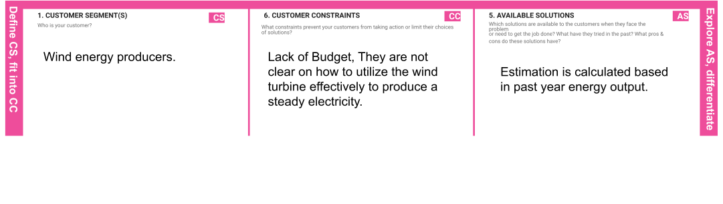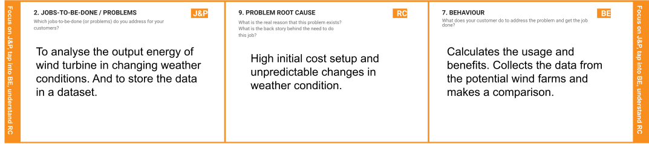



|  |  |  |  |  |
| --- | --- | --- | --- | --- |
|  | **3. TRIGGERS TR**  What triggers customers to act?  **If the customer ﬁnds it as an eﬃcient solution. It will automatically trigger all other customers to do it.** | **10. YOUR SOLUTION SL**  If you are working on an existing business, write down your current solution ﬁrst, ﬁll in the canvas, and check how much it ﬁts reality.  If you are working on a new business proposition, then keep it blank until you ﬁll in the canvas and come up with a solution that ﬁts within customer limitations, solves a problem and matches customer behaviour.  **The inlet condition of the wind turbine is forecasted by an auto regressive model. Hence it reduces the need for balancing energy and reserved power output energy.** | 1. **CHANNELS of BEHAVIOUR CH**    1. **ONLINE**   What kind of actions do customers take online?  **It will analyse the data which are previously uploaded and predict the output energy.**   * 1. **OFFLINE**   What kind of actions do customers take ofﬂine?  **The inlet condition of the wind turbine is maintained constantly.** |  |
| **4. EMOTIONS: BEFORE / AFTER EM**  How do customers feel when they face a problem or a job and afterwards?  **Before: Confused with improper energy ﬂow. After: Happy with the eﬃcient technique.** |